Demonstrative Adjectives

🔹 What Are Demonstrative Adjectives?
# Source: AI Source: Provided by: [Data Path: Persons Table -> ID Column: 1, Name_En Column: Motasem Essam] -> From: [Chatgpt (GPT-4-turbo)] on [7/27/2025]
Demonstrative adjectives are words that point to specific nouns and show their position or distance in relation to the speaker.
They answer the question: “Which one(s)?”

✅ The Four Demonstrative Adjectives Are:
# Source: AI Source: Provided by: [Data Path: Persons Table -> ID Column: 1, Name_En Column: Motasem Essam] -> From: [Chatgpt (GPT-4-turbo)] on [7/27/2025]
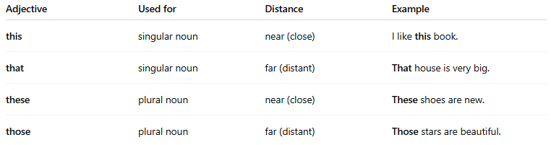
Adjective | Used for | Distance | Example
this | singular noun | near (close) | I like this book.
that | singular noun | far (distant) | That house is very big.
these | plural noun | near (close) | These shoes are new.
those | plural noun | far (distant) | Those stars are beautiful.

📚 Examples in Sentences
# Source: AI Source: Provided by: [Data Path: Persons Table -> ID Column: 1, Name_En Column: Motasem Essam] -> From: [Chatgpt (GPT-4-turbo)] on [7/27/2025]
- This pen is mine.
- That car belongs to John.
- These cookies are delicious.
- Those mountains look amazing.

🧠 Important Notes
# Source: AI Source: Provided by: [Data Path: Persons Table -> ID Column: 1, Name_En Column: Motasem Essam] -> From: [Chatgpt (GPT-4-turbo)] on [7/27/2025]
- They always come before a noun.
- If they stand alone (not followed by a noun), they are called demonstrative pronouns.
🔸 Adjective: I like this book.
🔸 Pronoun: I like this.

Demonstrative Adjectives vs. Demonstrative Pronouns
# Source: AI Source: Provided by: [Data Path: Persons Table -> ID Column: 1, Name_En Column: Motasem Essam] -> From: [Chatgpt (GPT-4-turbo)] on [7/27/2025]
Both demonstrative adjectives and demonstrative pronouns use the same four words:
this – that – these – those
But they play different roles in a sentence.

✅ Demonstrative Adjectives
# Source: AI Source: Provided by: [Data Path: Persons Table -> ID Column: 1, Name_En Column: Motasem Essam] -> From: [Chatgpt (GPT-4-turbo)] on [7/27/2025]
- Come before a noun
- Modify or describe that noun
- Answer "Which one?"
Examples:
- I love this movie.
- Those cookies are tasty.
- That chair is broken.
- These pencils are mine.
🔸 “this,” “that,” “these,” and “those” point to the noun.

✅ Demonstrative Pronouns
# Source: AI Source: Provided by: [Data Path: Persons Table -> ID Column: 1, Name_En Column: Motasem Essam] -> From: [Chatgpt (GPT-4-turbo)] on [7/27/2025]
- Replace a noun (stand alone)
- Do not come before another noun
- Refer to something already mentioned or known
Examples:
- This is my favorite.
- Those are expensive.
- I don’t like that.
- These are new.
🔸 They take the place of a noun rather than describe it.

📊 Comparison Table
# Source: AI Source: Provided by: [Data Path: Persons Table -> ID Column: 1, Name_En Column: Motasem Essam] -> From: [Chatgpt (GPT-4-turbo)] on [7/27/2025]
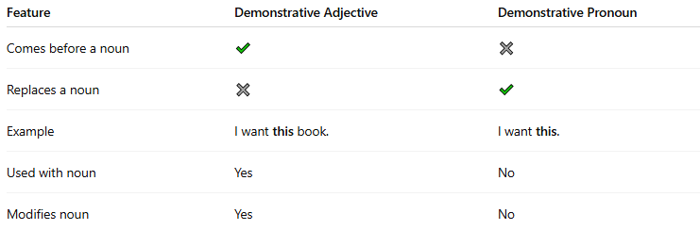
Feature | Demonstrative Adjective | Demonstrative Pronoun
Comes before a noun | ✔️ | ✖️
Replaces a noun | ✖️ | ✔️
Example | I want this book. | I want this.
Used with noun | Yes | No
Modifies noun | Yes | No

